Choice Price AB test result Update as of 2017-09-28 1:45 AM:

As of this Morning, 41 days into the test, the Test Group outperformed the Control Group in Revenue per Visitor,

1. The conversion rate of the Test Group is -8% lower than that of the Control Group
2. The ATS of the Test Group is +13% Higher than that of the Control Group
3. All in all, the Test Group is giving us a +4% lift in Revenue per Visitor over the control Group
4. Compared to the last update on September 18th, although the conversion rate deficit of the Test Group grew bigger over the ten-day period, the advantage of the ATS grew even more for the Test Group. As a result, the Revenue per Visitor advantage of the Test Group increased 2%. We will keep closely monitoring the test.

You can find the report here, <https://data.points.com/#/views/ChoicePriceTestAug_17/Summary?:iid=1>

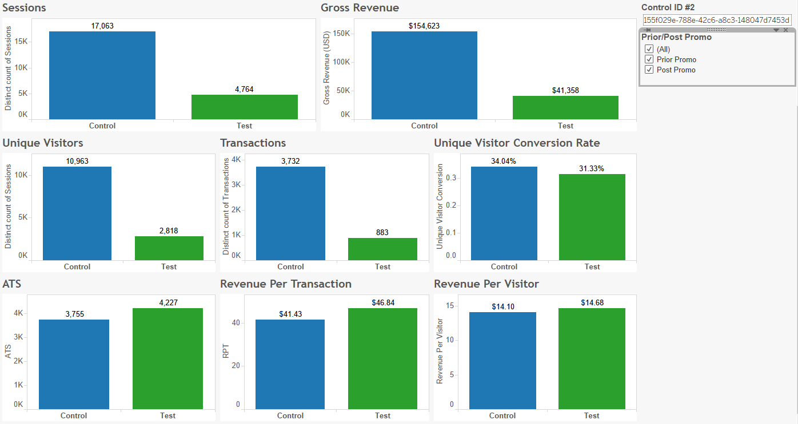

Post Promo

